Installation of Windows Subsystem for Linux - (WSL) method 1 (through windows power shell)

\*Open Windows powershell in administrator mode

\*go for the command to see available list in WSL

> wsl --list --online

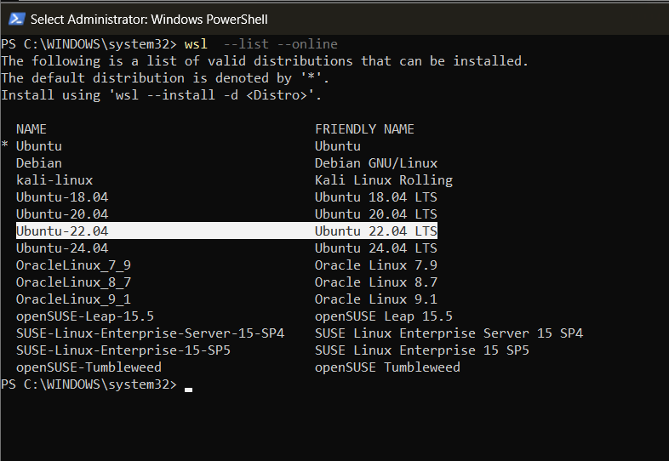

\*download the version suggested ( Ubuntu-22.04)

\* to install the specific Distro

> “ wsl --install -d <Distro>

> wsl –install -d Ubuntu-22.04

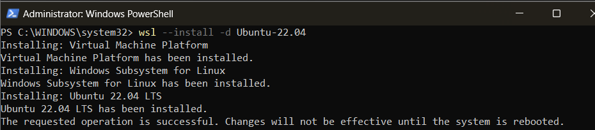

\*Open unbuntu in start menu (run as administrator)

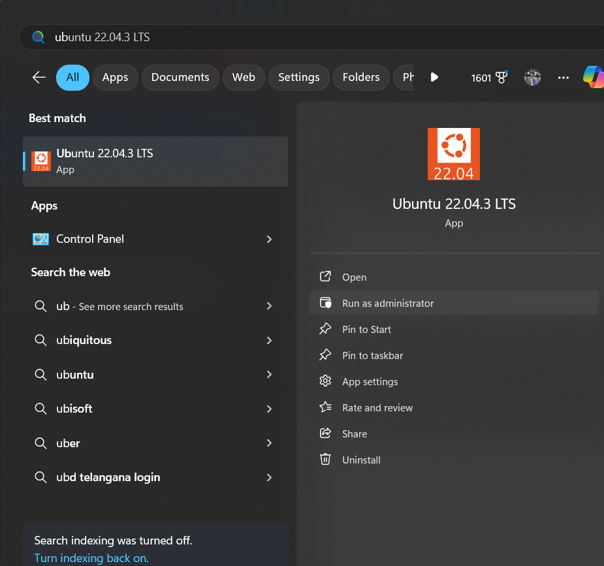

If this error occurs need to configure system settings

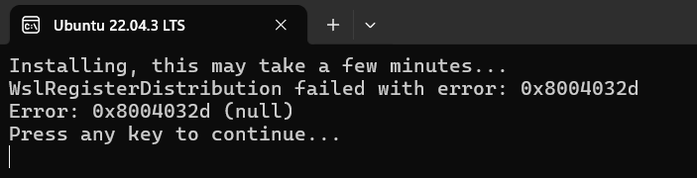

For that open search “Turn windows features on or off” open it

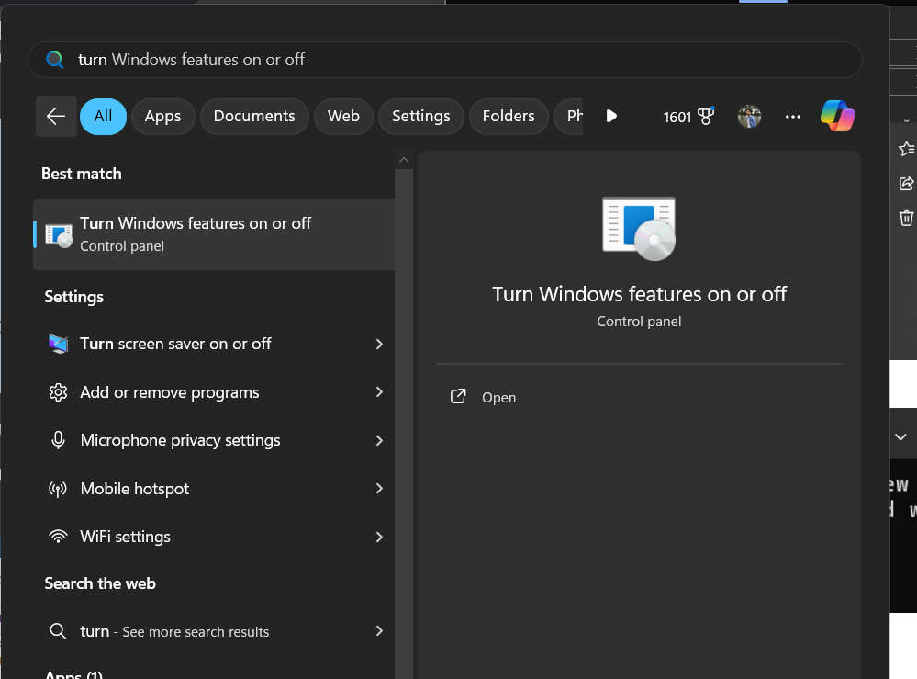

In that enable 2 options

1 Virtual machine Platform

2 Windows Subsysten for Linux then ok.

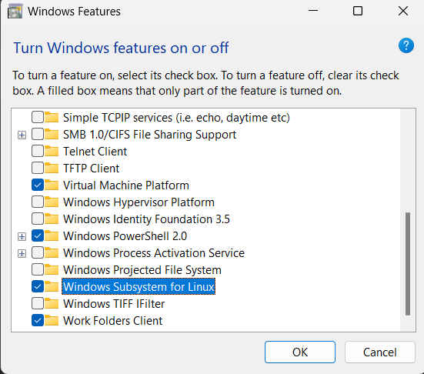

Then restart ur pc then open the ubuntu-22.04 in administration mode we get

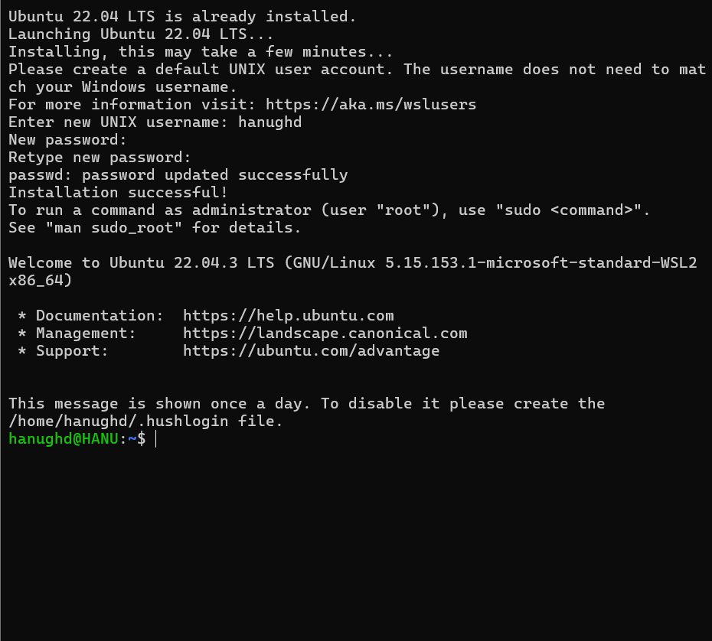

Set up Username and password for this

Then for any linux applications frst thing we will update the packages

* Sudo apt update

This is windows subsystem for linux installation

----------------------------------------------------------------------------------------------------------------------------------------------------

Installation of Windows Subsystem for Linux - (WSL) method 2 (through Microsoft store)

For that first we need to set up things like…





Then install Ubuntu-22.04 form Microsoft store then open it u will get directly user setup



Then we can perform

* Sudo apt update
* Sudo apt updrage
* Sudo apt install gcc

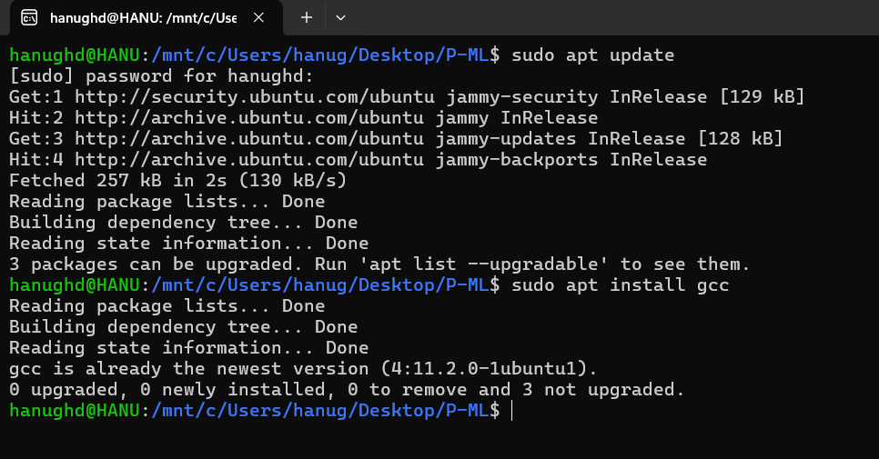

At start menu open wsl

After all the process to run the c programs frst need to set up the path location as files located

Sample programs saved with .c extension

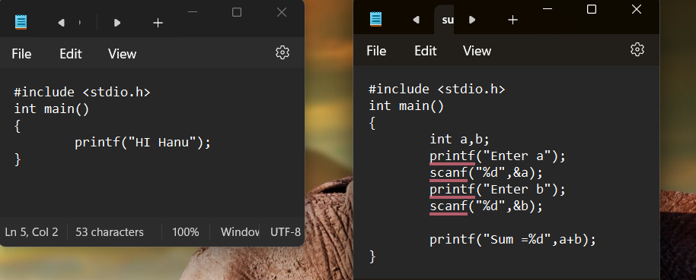

To execute enter following cmds

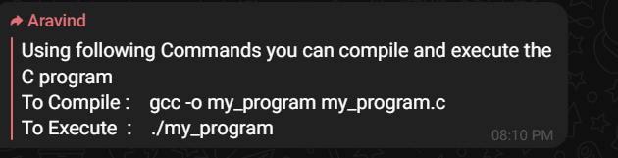

1 gcc -o filename filename.c

2 ./filename

Here 2 prgms hi.c, sum.c

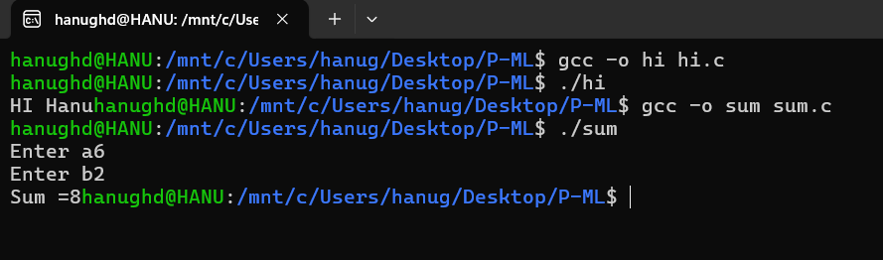

PYTORCH



Basics of pytorch: <https://www.javatpoint.com/basics-of-pytorch>

-------------------------------------------------------------------------------------------------------------------------------------------------